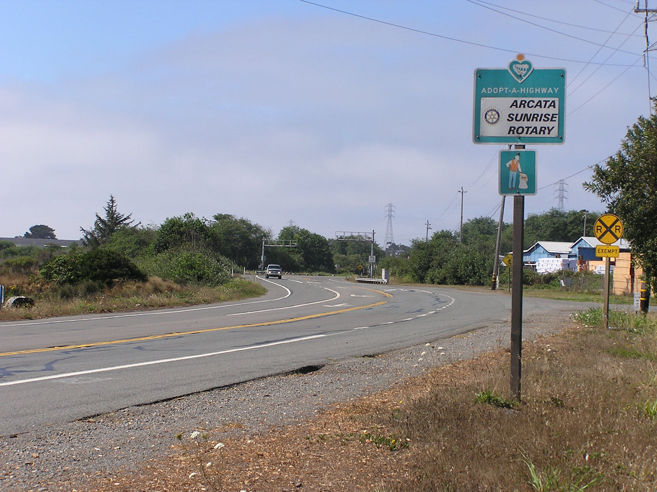

Arcata Sunrise Rotary Invites You!

Adopt a Highway

Saturday, August 24, 10am-11:30am.

*Followed by refreshments at Rita’s in Arcata!*

**Meet at the Humboldt Coastal Nature Center, 220 Stamps Lane in Manila**

